**Platform as a Service**

PAAS is a cloud computing model that provides users a complete development and deployment environment in the cloud, including hardware, software, and infrastructure, which enables them to develop, manage and deploy applications with ease. Moreover, it is flexible when compared to the on-premise platforms.

The PAAS service provider hosts every resource at their own data center, which include programming languages, application frameworks, networks, storage, servers, operating systems software, databases, development tools, etc. The customers have the flexibility to purchase the resources on a pay-as-you-go basis that gives them the chance to pay only for those resources they use. This type of pricing allows them to have their applications on cloud more quickly and with less cost.

The principle involved in PAAS is the user have to manage the programs (applications) and services he/she develop, while the cloud service provider takes care of the rest.

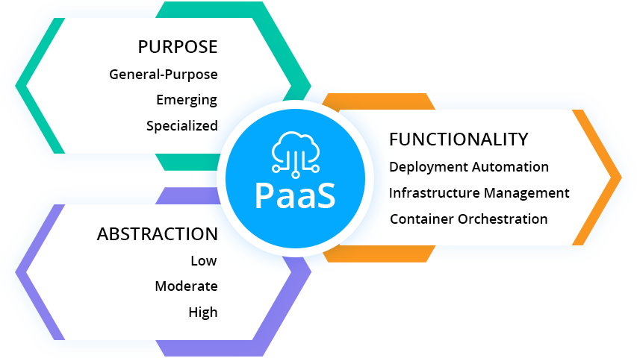

**Figure-1: Features of PAAS**

Figure-1 describes the characteristics of PAAS in terms of its purpose, functionality and abstraction.

**Usecases of PAAS:**

* **Development framework:**

PAAS provides an infrastructure that lets developers build their applications using built-in software components and spend less time on coding.

* **Analytics or business intelligence:**

PAAS provides the tools that allow organizations to perform analytics on their data which help them improve their business decisions when necessary.

**Popular PAAS service providers:**

Google App Engine, Salesforce.com, Windows Azure, OpenShift, Cloud Foundry from VMware

**Popular examples of PAAS:**

AWS Elastic Beanstalk, Windows Azure, Heroku

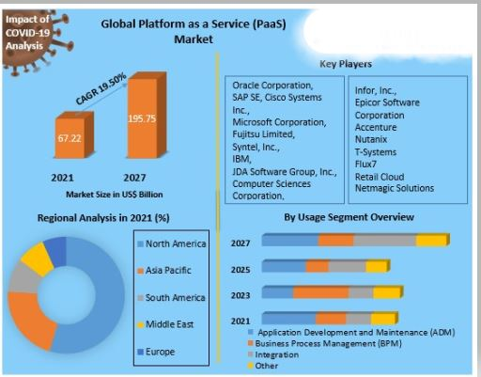

**Figure-2: Analysis and Overview of PAAS market from 2021 to 2027 [1]**

Figure-1 depicts the impact of PAAS in global market during the COVID-19. Also, the key organizations which used PAAS and the usage segment was shown in the figure above.

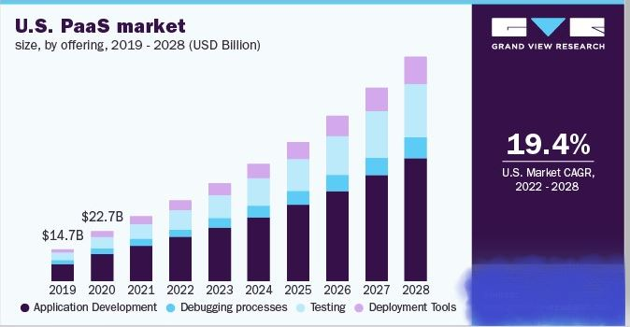

**Figure-3: Trend of US PAAS market in four areas for 10 years [2]**

Figure-3 tells us the four sectors of US market where PAAS is being used from 2019 and forecasts its usage in the coming years till 2028. Of the four stages of application lifecycle, Application Development, Debugging, Testing, and Deployment, PAAS was more used for Application Development and is likely to have the high usage in the coming years even. Overall, 19.4% of US market is expected to have PAAS in 2022-2028.

**Conclusion:**

In conclusion, nowadays many organizations use PAAS to focus on building their applications with readily available code and software without worrying about the infrastructure and operating systems. This enables faster time to market. It also allows businesses to easily supervise their applications on cloud without the difficulties of having their own resources. All the major organizations like Oracle, Microsoft, IBM, Accenture are already using PAAS for building their applications.

From Figure-1, we understand that PAAS can be used in General, Emerging and Specialized purposes. It is also efficient to hide the features of applications and depict only the necessary ones.

With the increase in use of PAAS that provides online communities, developers share their work and receive suggestions from others which help them get new ideas. From Figure-2, the PAAS market share was high for North America in 2021 being 67.22 billion dollars. It is expected to have a 19.50% rise by the year 2027 indicating more usage of cloud in future.

**References:**

1. <https://www.maximizemarketresearch.com/market-report/global-platform-as-a-service-paas-market/62017/> - Maximize Market Research Private Limited’s analysis on PAAS impact during the pandemic.
2. <https://www.grandviewresearch.com/industry-analysis/paas-market-report> - Grand View Research report on PAAS market size, share & trends.

**Please leave the queries and comments in the comment section.**